Now that you have gotten used to Java’s Swing library to build GUIs, you will rewrite your Battleship project using a graphical user interface. You are free to use your code from your last project, the code we developed in class and/or my solution. You may **not** use any GUI code that is not your own.

**Part 1 – Creating the Interface**

When the program begins, it must load the following screen:

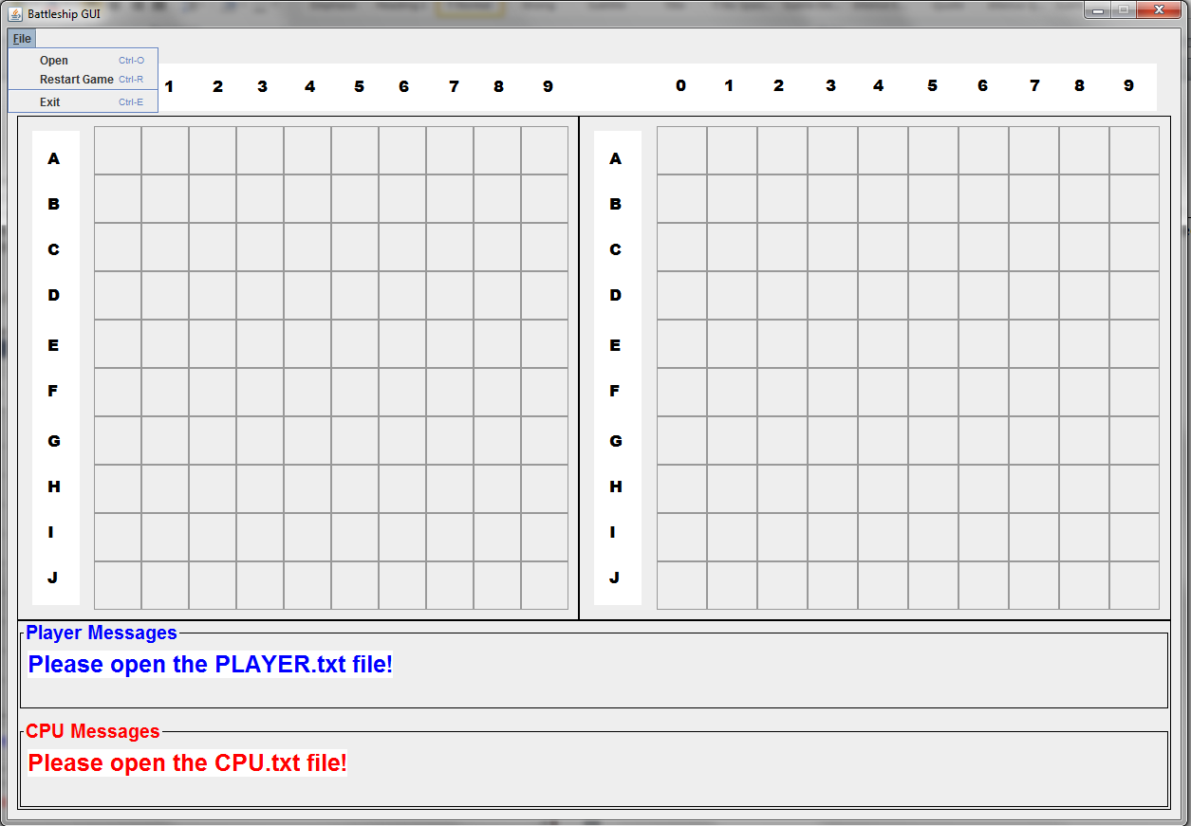

Don’t worry about user input until you get the GUI properly laid out; this will save you a lot of time later. When the user sees this screen, there is nothing to interact with except the menu. In other words, click on the empty grid will not do anything. You will find the following resources useful:

* [JMenu tutorial](http://docs.oracle.com/javase/tutorial/uiswing/components/menu.html)
* [JFileChooser tutorial](http://docs.oracle.com/javase/tutorial/uiswing/components/filechooser.html)
* [Using BorderLayout with JPanel](http://www.youtube.com/watch?v=vSLY5ws0Rfo)

**Part 2 – Loading the Board Files**

Like last time, the player and cpu boards will be loaded via files named PLAYER.TXT and CPU.TXT, respectively. See the following images as they are self-explanatory:

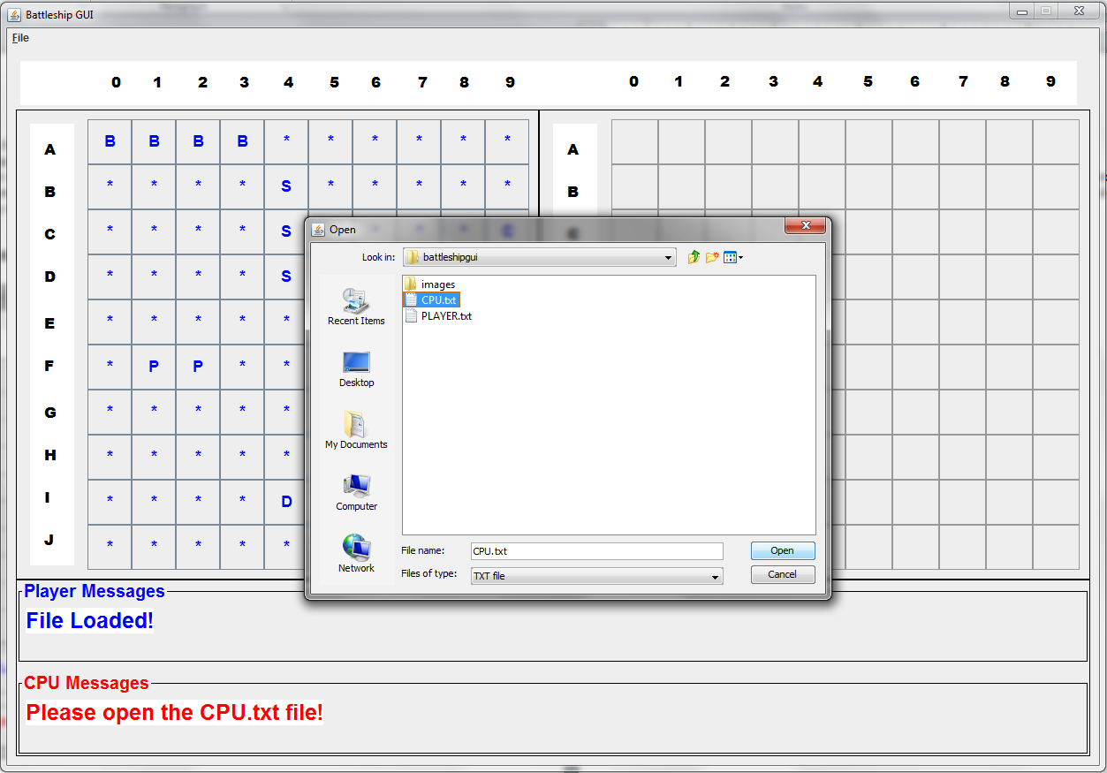

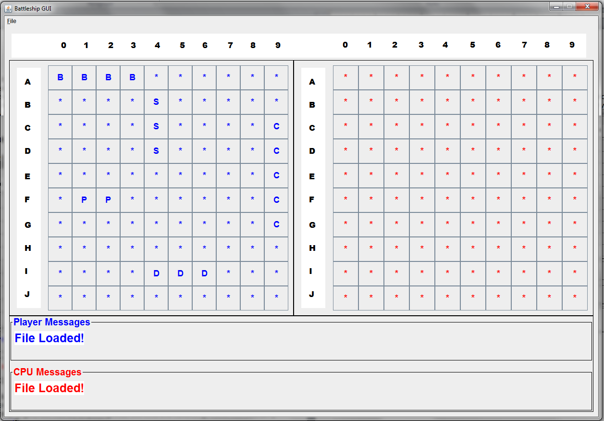

Once the files are loaded, the game can begin and the right-side buttons become active.

**Part 3 – Making Moves**

The following screenshots cover all the scenarios you will run into:

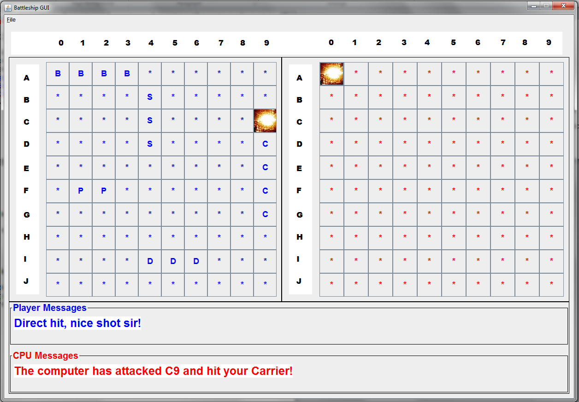

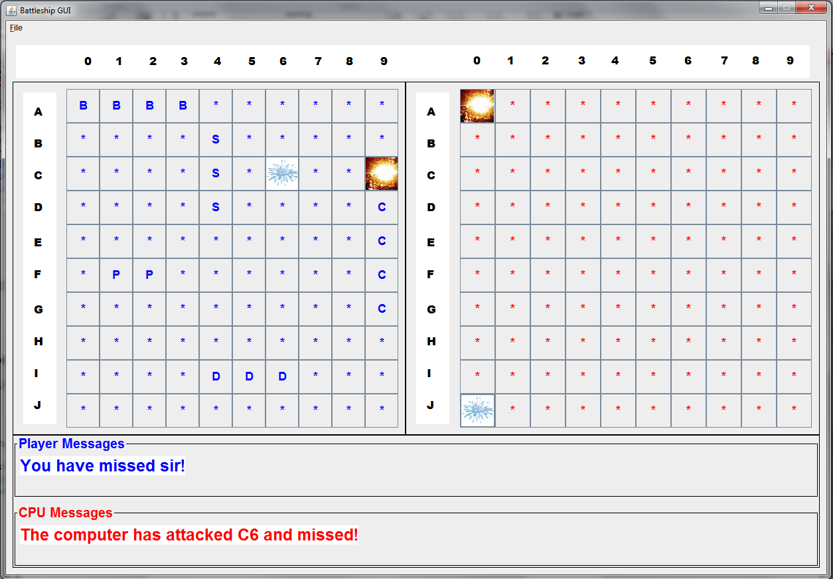

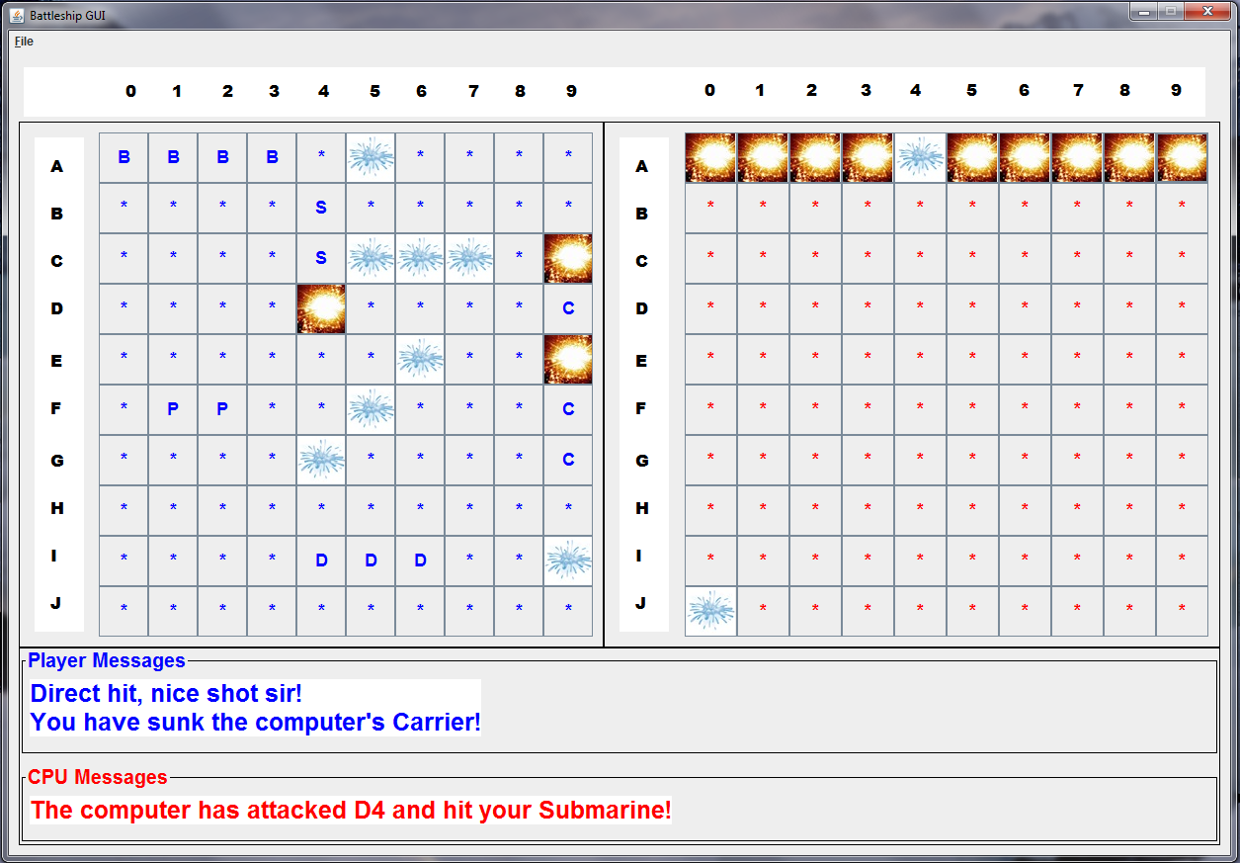

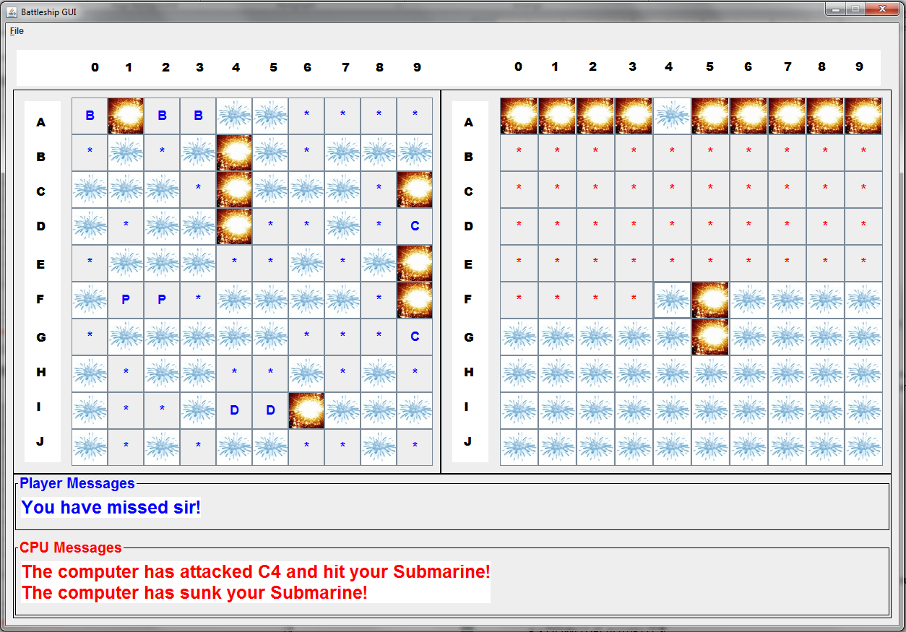

**Part 4 – Winner**

Upon victory, a dialogue box should announce the winner, and neither player should be allowed to make further attacks. See the following image:

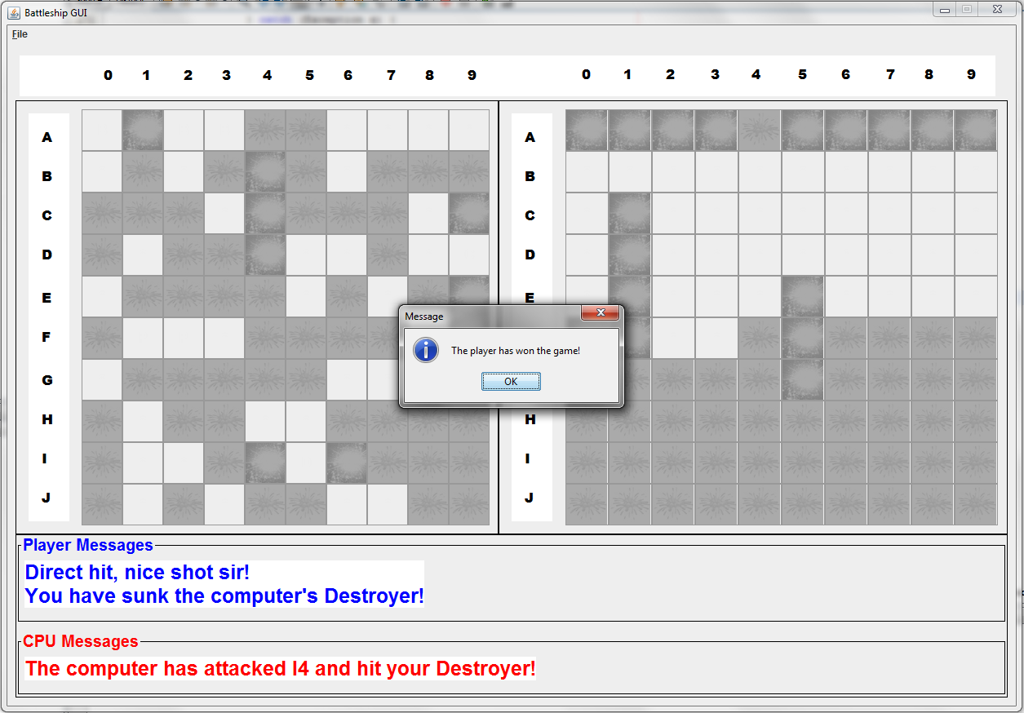

**Part 5 – Restart**

When the “Restart Game” menu is selected, the program reverts to its starting state.

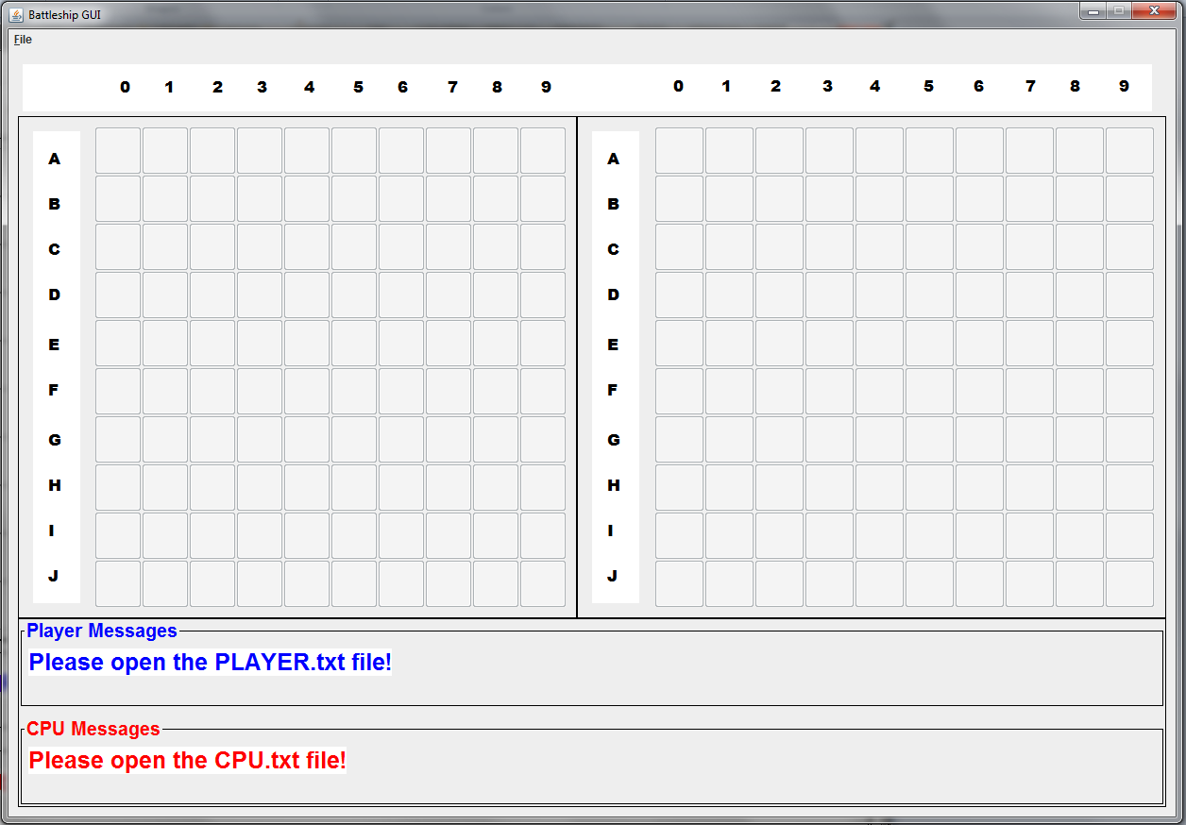

**Part 6 – Exit**

This menu option will cause the program to terminate.

**Additional Notes:**

* DO NOT PLAGIARIZE
* Do not procrastinate
* Follow proper coding conventions 🡺 spacing, naming, commenting, … etc
* You **must** work in groups of two
* You must not exceed 400 lines of code

**Due Date:** Friday, March 23, 2018 in class